|  |  |
| --- | --- |
| TALLINN UNIVERSITY OF TECHNOLOGY | |
| School of Information Technologies | |
|  | |
|  | |
| Karl Oskar Anderson 185611IADB | |
| Creating a food ordering environment | |
| Course work | |
| Supervisor: | Andres Käver |
|  |  |
|  |  |
|  |  |
|  |  |
|  |  |
|  |  |
|  |  |
|  |  |
|  |  |

|  |  |
| --- | --- |
| tallinna tehnikaülikool | |
| Infotehnoloogia teaduskond | |
|  | |
|  | |
| Karl Oskar Anderson 185611IADB | |
| toidu tellimise keskkonna loomine | |
| Kursuse iseseisev töö | |
| Juhendaja: | Andres Käver |
|  |  |
|  |  |
|  |  |
|  |  |
|  |  |
|  |  |
|  |  |
|  |  |
|  |  |

**Author’s declaration of originality**

I hereby certify that I am the sole author of this thesis. All the used materials, references to the literature and the work of others have been referred to. This thesis has not been presented for examination anywhere else.

Author: Karl Oskar Anderson

22.02.2020

Table of contents

**Author’s declaration of originality** 2

Table of contents 3

List of figures 4

1 Introduction 5

2 Project 6

List of figures

**Figure 1: ERD – diagraph of the food ordering environment**

2 Database *soft delete* and *soft update*

Author used Azure Data Studio to test different solutions on implementing *soft delete* and *soft update* on the project database. *Soft delete* in essence means that data is never deleted from a database, but rather marked as expired and SQL queries will have to be adjusted to filter these results out. *Soft update* means that database entries cannot be directly updated, but a new entry will be made, its exact relationship to other data will largely depend on the implementation.

In general *soft delete* is a bad idea, with few exceptions. Implementing them as a matter of course, regardless of the actual needs of their application is foolish. Their use as a data loss is trivial as databases should be backed up as archives regularly and data loss prevention by natural causes is neglected by 2-step delete-update process. They increase database size and complexity significantly. Performance decreases, but using an additional table to separate storing deleted data and active data somewhat mitigates this along with partitioning tricks. On a development standpoint omitted WHERE clauses will result in chaos. There is no agreed upon solution on implementation and a great number of workaround have to be made It only has a niche use in preventing invalid deletes and keeping track of every data change that is required when dealing with financial data.

1 Introduction

The author noticed the shortcomings of the food ordering environments currently on the market and thus decided to develop his own vision.

The author believes that the design of the project symbolizes a snow-capped mountain top of his university journey. The author respects his own desire to embark upon this wide-eyed journey to emerge in the end feeling tired, slightly crushed, less naive perhaps, but ultimately beaming with accomplishment. Provided he does not find his end on the way that is.

The author prepares a project that he sells to companies operating within the bounds of a particular country, who are primarily engaged in preparing end-user customizable foods like pizza and serving them to customers. All food servicing companies will hereinafter be referred to collectively as restaurants. The project is of interest to companies that are satisfied with this solution and the end customers are private individuals who want to order a seal. In essence the author has a fictional client, business owner X, who wants to create a web service solution for their company Y in order for the company to operate online.

Soft update is demonstrated by creating a Person table. Person table has a compound primary key of Id and DeletedAt. While updating entries the old entry is updated directly changing its CreatedAt value alongside the intended update changes then a new entry will be created that will be identical to the old entry besides the DeletedAt field that will match the new entries CreatedAt. This approach will mean that no foreign reference integrity will be broken. Also Id will act uniquely in terms of separate objects. This property can be exploited to sort all object updates and take the top 1.

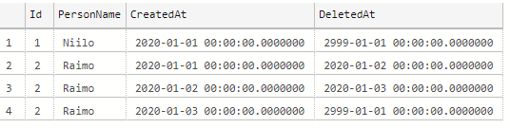

In addition to Person table we have a User table. Users might be connected to a person, but there is also the possibility that User is just a shared account among admins. A person is not necessarily a user, but a person is required when a user makes a invoice on the behalf of someone else. In that case the User will have Person reference as null. For mentioned examples letter T is added to avoid SQL Server keywords and have no other meaning.

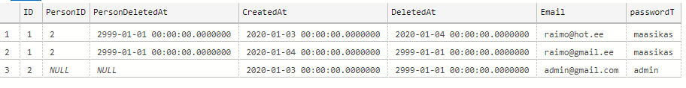

For meals there need to be a opportunity for one meal to have multiple prices depending on the UserGroup and Restaurant, that will be implemented later. A price change should be doable beforehand so no one has to change hundreds of meal prices at midnight.

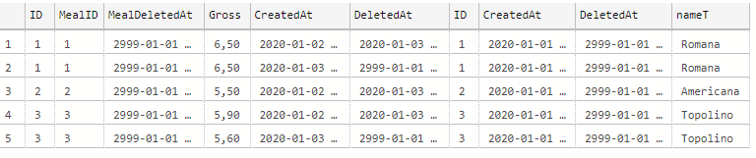

2 Project

Let there be a website www.ZY.ee where company administrators can create their own user accounts. Company administrators have rights to manage descriptions of their restaurants, add food to menus, change menus and change food prices.

Restaurants have a menu; the same menu may be used in different restaurants. When ordering food, the user simply has to choose the restaurant of his choice. Food is divided into categories: pizzas, drinks, desserts etc. Users should not be confused, all foods should be listed on a single page – meaning category is not recursive. One product can only be under one category. The pizzas on the menu are not definitive; the pizzas have a variety of sizes, bases and additional components that the customer specifies on purchase.

The food prices are determined by individual restaurants. The same food may be differently priced in different restaurants. All pizzas have a base price and basic components. The components of the pizza can be modified and added up to a certain limit. It must be possible to add one component to the same pizza several times. Removing the basic components will not reduce the price of the pizza. Basic components can be removed to some extent and new components can be added step by step. The components have a price, but the price of the basic components is included in the basic price of the pizza. Removing the basic pizza components will not reduce the price of the pizza, but you can add more components in place of the removed component. If the added component is more expensive than the removed base component, the difference will have to be paid by the customer; if lower, the customer will still have to pay the basic pizza price.

Meals do not have prices in multiple currencies, but there can be several prices for one meal at a given time. Users belong to customer groups; prices vary for different customer groups. If the user belongs to more than one customer group, the lowest price is assigned to the user. Price will be displayed in gross, net prices will be calculated to receipt by tax.

The customer can add food to their cart. The customer can choose the type of food handover: carryout/dine-in or by courier delivery. When ordering by courier, the customer must specify the delivery address. The address is saved under the user's account so that the food delivered to the same location will not need to be refilled next time. The invoice is issued not to the user but to a person, nevertheless the buying user will pay. The person who receives the food may not be the owner of the user account who paid the invoice. An invoice consists of invoice lines. The invoice lines are not related to the price of food, otherwise the existing invoices will change as the price of the food changes (unless a significantly more advanced solution is used). Invoice rows cannot be changed- they are permanent. Calculating fees or physical limitations of the courier is beyond the scope of this project, we expect the pizzas to arrive free, anywhere and instantaneously.

The invoice can be shared between friends of the user. This is a useful feature for events, where one person is responsible for providing food for a group and compensation is expected. A new share item is created in order to share the invoice. Shared foods come from invoice lines. Manually selecting single invoice rows would not be user friendly, so sharing meals will be generated based on the invoice. Users can share foods with their friends at a percentage and the system calculates how much money that friend owns them. Unallocated foods are the property of the user.

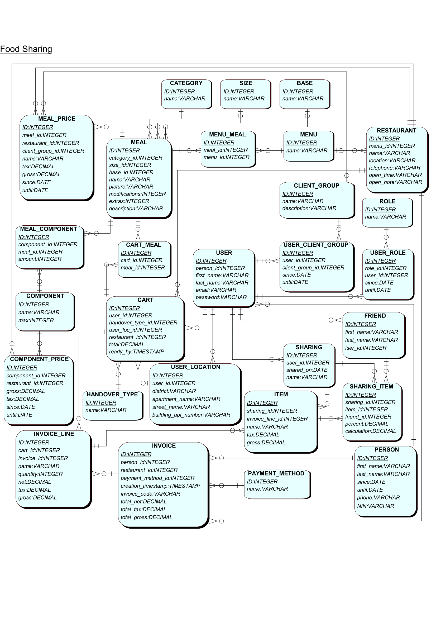

Figure 1: ERD – diagraph of the food ordering environment

Extras

IF db_id('kaande.kaande_softdelete') IS NOT NULL BEGIN

    USE master

    DROP DATABASE "kaande.molder_softdelete"

END

GO

CREATE DATABASE "kaande.kaande_softdelete"

GO

USE "kaande.kaande_softdelete"

GO

-- Single table

CREATE TABLE Person (

    Id      INT             NOT NULL,

    PersonName    VARCHAR(128)    NOT NULL,

    CreatedAt DATETIME2     NOT NULL,

    DeletedAt DATETIME2     NOT NULL,

    PRIMARY KEY (Id, DeletedAt)

)

DECLARE @Time1 DATETIME2

SELECT @Time1 = '2020-01-01'

DECLARE @Time0 DATETIME2

SELECT @Time0 = '2999-01-01'

INSERT INTO Person (Id, PersonName, CreatedAt, DeletedAt) VALUES (1 ,'Niilo', @Time1, @Time0)

INSERT INTO Person (Id, PersonName, CreatedAt, DeletedAt) VALUES (2, 'Raimo', @Time1, @Time0)

DECLARE @Time2 DATETIME2

SELECT @Time2 = '2020-01-02'

UPDATE Person SET CreatedAt = @Time2 where Id = 2 and DeletedAt = @Time0;

INSERT INTO Person (Id, PersonName, CreatedAt, DeletedAt) VALUES (2, 'Raimo', @Time1, @Time2);

DECLARE @Time3 DATETIME2

SELECT @Time3 = '2020-01-03'

UPDATE Person SET CreatedAt = @Time3 where Id = 2 and DeletedAt = @Time0;

INSERT INTO Person (Id, PersonName, CreatedAt, DeletedAt) VALUES (2, 'Raimo', @Time2, @Time3);

SELECT 'Initial data'

SELECT * FROM Person

SELECT * FROM Person where Id = 2 ORDER BY DeletedAt;

-- 1:0-1

CREATE TABLE UserT (

    ID      INT             NOT NULL,

    PersonID INT            NULL,

    PersonDeletedAt DATETIME2   NULL,

    CreatedAt DATETIME2     NOT NULL,

    DeletedAt DATETIME2     NOT NULL,

    Email VARCHAR(64)       NOT NULL,

    passwordT VARCHAR(64)   NOT NULL,

    FOREIGN KEY (PersonID, PersonDeletedAt) REFERENCES Person(Id, DeletedAt),

    PRIMARY KEY (ID, DeletedAt)

)

DECLARE @Time0 DATETIME2

SELECT @Time0 = '2999-01-01'

DECLARE @Time1 DATETIME2

SELECT @Time1 = '2020-01-01'

DECLARE @Time3 DATETIME2

SELECT @Time3 = '2020-01-03'

DECLARE @Time4 DATETIME2

SELECT @Time4 = '2020-01-04'

INSERT INTO UserT (ID, PersonID, PersonDeletedAt, CreatedAt, DeletedAt, Email, PasswordT) VALUES (1, 2, @Time0, @Time3, @Time0, 'raimo@hot.ee', 'maasikas')

INSERT INTO UserT (ID, PersonID, PersonDeletedAt, CreatedAt, DeletedAt, Email, PasswordT) VALUES (2, NULL, NULL, @Time3, @Time0, 'admin@gmail.com', 'admin')

SELECT 'Initial data'

SELECT * FROM UserT

UPDATE UserT SET CreatedAt = @Time4, Email= 'raimo@gmail.ee' where Id = 1 and DeletedAt = @Time0;

INSERT INTO UserT (ID, PersonID, PersonDeletedAt, CreatedAt, DeletedAt, Email, PasswordT) VALUES (1, 2, @Time0, @Time3, @Time4, 'raimo@hot.ee', 'maasikas');

DECLARE @Time3 DATETIME2

SELECT @Time3 = '2020-01-03'

SELECT UserT.ID, UserT.CreatedAt, UserT.DeletedAt, UserT.Email, UserT.passwordT, Person.Id, Person.CreatedAt,

Person.DeletedAt, Person.PersonName FROM UserT INNER JOIN Person on UserT.PersonID = Person.Id AND

UserT.PersonDeletedAt = Person.DeletedAt WHERE UserT.CreatedAt > @Time3;

-- 1:m

CREATE TABLE Meal (

    ID      INT             NOT NULL,

    CreatedAt DATETIME2     NOT NULL,

    DeletedAt DATETIME2     NOT NULL,

    nameT VARCHAR(64)       NOT NULL,

    PRIMARY KEY (ID, DeletedAt)

)

CREATE TABLE Meal_Price (

    ID      INT             NOT NULL,

    MealID INT              NULL,

    MealDeletedAt DATETIME2     NOT NULL,

    Gross DECIMAL(18,2)           NULL,

    CreatedAt DATETIME2     NOT NULL,

    DeletedAt DATETIME2     NOT NULL,

    FOREIGN KEY (MealID, MealDeletedAt) REFERENCES Meal(ID, DeletedAt),

    PRIMARY KEY (ID, DeletedAt)

)

DECLARE @Time0 DATETIME2

SELECT @Time0 = '2999-01-01'

DECLARE @Time1 DATETIME2

SELECT @Time1 = '2020-01-01'

DECLARE @Time2 DATETIME2

SELECT @Time2 = '2020-01-02'

DECLARE @Time3 DATETIME2

SELECT @Time3 = '2020-01-03'

INSERT INTO Meal (ID, CreatedAt, DeletedAt, nameT) VALUES (1, @Time1, @Time0, 'Romana')

INSERT INTO Meal (ID, CreatedAt, DeletedAt, nameT) VALUES (2, @Time1, @Time0, 'Americana')

INSERT INTO Meal (ID, CreatedAt, DeletedAt, nameT) VALUES (3, @Time1, @Time0, 'Topolino')

INSERT INTO Meal_Price (ID, MealId, MealDeletedAt, Gross, CreatedAt, DeletedAt) VALUES (1, 1, @Time0, 6.50, @Time2, @Time3)

INSERT INTO Meal_Price (ID, MealId, MealDeletedAt, Gross, CreatedAt, DeletedAt) VALUES (1, 1, @Time0, 6.50, @Time3, @Time0)

INSERT INTO Meal_Price (ID, MealId, MealDeletedAt, Gross, CreatedAt, DeletedAt) VALUES (2, 2, @Time0, 5.50, @Time2, @Time3)

INSERT INTO Meal_Price (ID, MealId, MealDeletedAt, Gross, CreatedAt, DeletedAt) VALUES (3, 3, @Time0, 5.90, @Time2, @Time0)

select * from Meal_Price

select top 1 * from Meal_Price where ID = 1 ORDER by CreatedAt desc

UPDATE Meal_Price SET CreatedAt = @Time3, Gross = 5.60 where Id = 3 and DeletedAt = @Time0;

INSERT INTO Meal_Price (ID, MealId, MealDeletedAt, Gross, CreatedAt, DeletedAt) VALUES (3, 3, @Time0, 5.90, @Time2, @Time3);

SELECT UserT.ID, UserT.CreatedAt, UserT.DeletedAt, UserT.Email, UserT.passwordT, Person.Id, Person.CreatedAt,

Person.DeletedAt, Person.PersonName FROM UserT INNER JOIN Person on UserT.PersonID = Person.Id AND

UserT.PersonDeletedAt = Person.DeletedAt WHERE UserT.CreatedAt > @Time3;

DECLARE @Time1 DATETIME2

SELECT @Time1 = '2020-01-01'

select * from Meal_Price INNER JOIN Meal on Meal_Price.MealID = Meal.ID AND

Meal_Price.MealDeletedAt = Meal.DeletedAt WHERE Meal_Price.CreatedAt > @Time1;